Program3

test4.dat ,DF=1

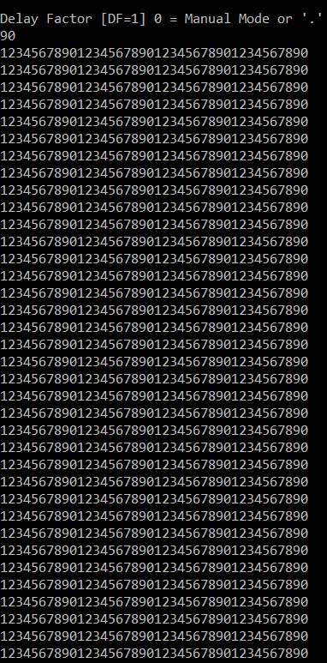

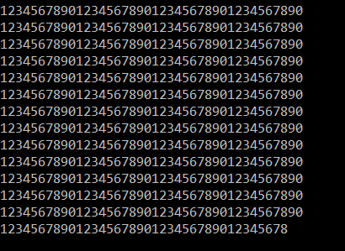

Program3

Test.dat ,DF=3

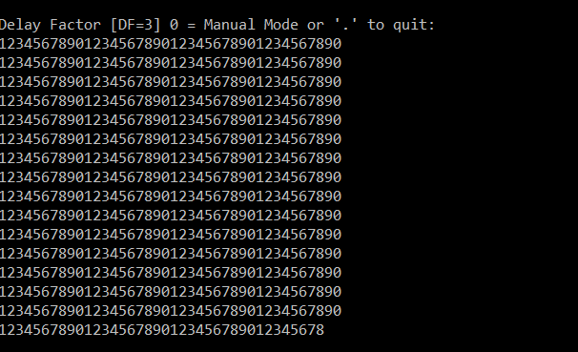

Program2, ProcTime=100000

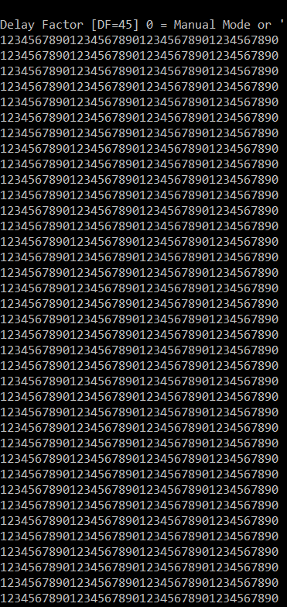

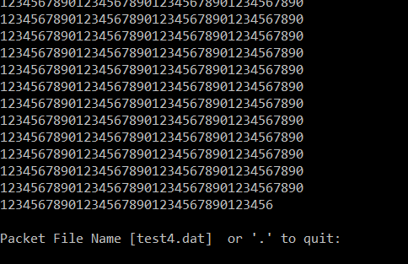

Program3 Proctime :100000

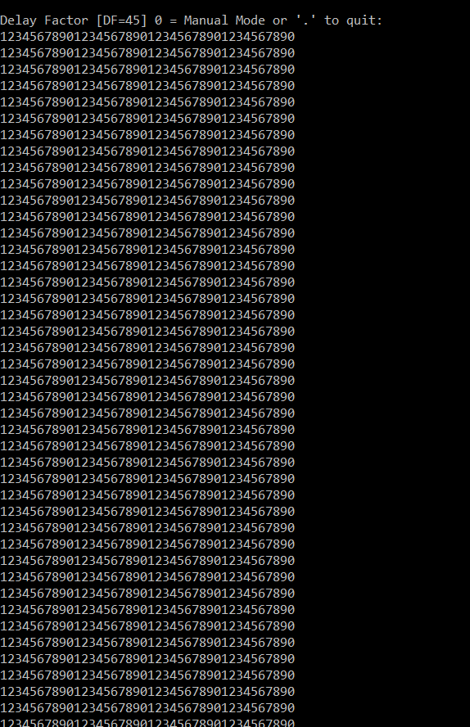

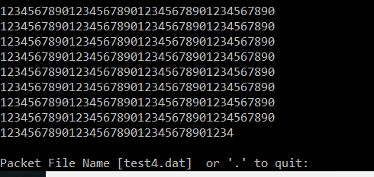

|  |  |
| --- | --- |
| **Program** | **Minimum COMAPP Delay Factor with Proc time 10000** |
| Program 2 | 45 |
| Program 3 | 45 |